英语 九年级全册
Unit 7 | Teenagers should be allowed to choose their own clothes. | Period 4 | Content Section B 1a, 1b, 1c, 1d, 1e
教学目标要求
1．能够掌握表达同意的会话功能， 如：I agree.
2．能够掌握表达不同意的会话功能，如：I don’t agree.
3．能正确使用 “情态动词+被动语态”结构，如：should be done等。
4．能听懂关于 人物经历的对话，如：1c, 1d。
5．能表达对于某项规定的看法，如：Peter should be allowed to take the test later.
6．能模仿录音正确朗读和表演教材上的对话，并能模仿目标语的结构和语调进行初步表达(会话)。

教学过程
活动 | 步骤 | 教与学活动目的及其操作 | 教学资源运用
复习  时间  2 m | 1 | 复习已学目标语。  Look at the phrases. Do you think teenagers should be allowed to do these things? Give us your opinion. For example: I think teenagers should be allowed to drive.  展示短语，并就短语内容让学生复述上一课所学句子。 | 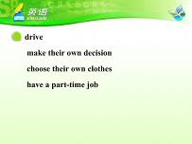
导入  时间  2 m | 2 | 导入本课标题。  教师板书或课件显示：  Unit 7 Teenagers should be allowed to choose their own clothes. Period 4 | 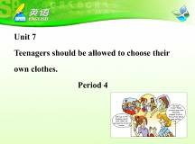
导入  时间  2 m | 2 | 讨论目标句式。  Can you think of a time when you were late for class? When was that? How often do you get to class late?  Have you ever studied with friends? How often? Where do you usually study?  Have you ever finished a test early? Why did you finish it early?  Do you often worry about failing a test?  What do you do if you worry about it?  教师提问与学生轻松聊天，引起他们对自己学习生活的记忆。要求学生用完整的句子回答。可以先点基础好的学生，更具有示范性。有些问题可以多次问不同的学生。 | 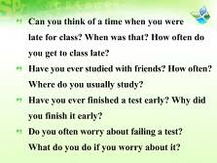
导入  时间  2 m | 3 | 引入本课话题，激活学生记忆。  教师提问，引入本课话题。  What happened to the boy at the door in the picture?  引导学生读图，并让学生回答从图中得到的信息。如：The boy is late for class. The teacher is angry. | 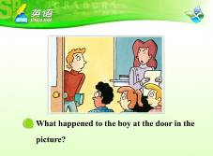
1a  时间  5 m | 4 | 读1a标题，抓住话题大意。 | 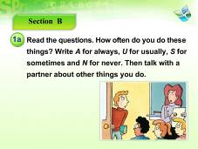
 | 5 | 完成目标练习。  Look at the phrases. Write A for always, U for usually, S for sometimes and N for never.  让学生根据自己的情况完成1a。并让学生用完整的句子核对答案，如：I never go to class late. | 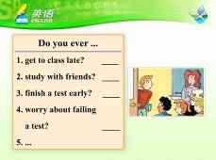
1b  时间  6 m | 6 | 对话练习目标语。  Work in pairs and talk about these points.  两人结对完成1b， 展示部分学生的对话。 | 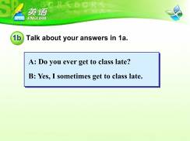
1c  时间  6m | 7 | 看图预测听力内容。  Look at the question and guess what we will listen in the tape.  让学生根据问题猜测听力内容。 | 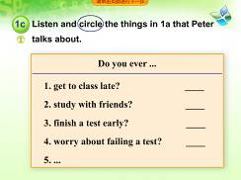
1c  时间  6m | 8 | 读问题，预测听力内容。  Let’s listen to the tape and find out: What is Peter talking about?  先设一个听力目标，连贯的播放一遍录音，请同学回答听力目标问题，至少问三位同学，教师不给答案。但要求说出听力中的原句。
1c  时间  6m | 9 | 听录音回答问题。  Listen to the tape and circle the things that Peter talks about.  播放第二遍录音，学生完成1c，并核对答案。 | 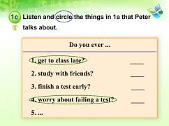
1d  时间  5 m | 10 | 阅听力材料，了解目标语。  Look at the sentences in 1d. What should the sentences be?  引导学生听前读材料，并进行猜测。 | 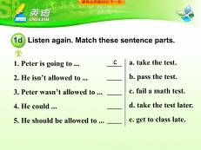
1d  时间  5 m | 11 | 听录音，完成排序。  Listen to the tape and match the sentences.  播放录音，提醒学生按意羣的停顿去捕捉信息，完成1d。 | 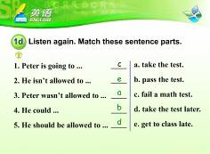
1d  时间  5 m | 12 | 朗读句子，进一步理解目标语。  Let’s read the sentences together.  让学生朗读已经连线的句子。
1d  时间  5 m | 13 | 听录音，进一步理解对话。  Listen to the tape again and answer my questions.  1. Is Peter worried about his math test?  2. Did Peter get to school late?  3. Is he allowed to be late for class?  4. Was he allowed to take the test after he got to class?  5. How did he feel about his test?  6. What did his father mean …?  7. What is his father’s advice?  再听录音，在放录音的过程中，教师要不断的提问帮助学生理解，引起他们对某些关键句子的关注或者引发他们思考。 | 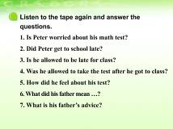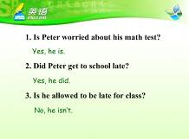  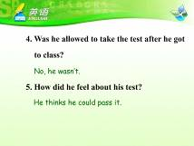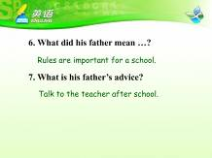
1e  时间  6 m | 14 | 进一步讲解目标语，加深学生理解。  Do you think Peter should be allowed to take the test later? Why or why not?  Is it fair or unfair for the other students if Peter takes the test later?  Will more students get to class late if Peter is allowed to take the test later?  Why do students need strict rules?  Do you think a school has to have rules?  What will happen if there are no rules at school?  Does a rule tell you what is right and what is wrong?  Are your parents too strict with you? Is it good or bad?  Do you like the rules? Why or why not?  通过问题，与学生讨论对话内容，让学生发表自己的观点。 | 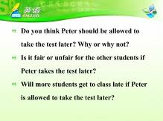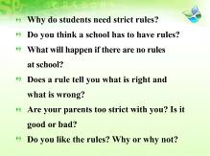
1e  时间  6 m | 15 | 对话练习，进一步掌握目标语。  Work in groups and talk about the points.  给出例句让学生练习，之后找几组学生起来展示。 | 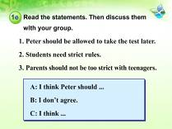
小结  时间  2 m | 16 | 总结本课所学目标语。  What have you learned from this lesson?  鼓励学生先自己总结，教师最后归纳。  让学生朗读1d的句子。
拓展  时间  5 m | 17 | 拓展活动：讲述自己的故事。  让学生根据自己的经历给大家讲述自己之前的某个过错以及自己所得到的惩罚，并发表自己对这件事的看法。如：I didn’t clean my room last week because I had too much homework that day. And my mom was angry. She made me clean the whole house. I don’t think I should clean the whole house. | 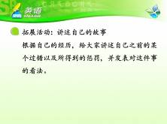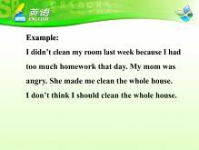
作业  1 m | 18 | Homework(布置作业) | 

